Maternal behaviour in rabbit سلوك الامومه فى الارانب
Maternal behaviour in rabbits includes 4 items يتكون سلوك الامومه فى الارانب من اربعه عناصر وهى
1-Nest box behaviourسلوك بناء العش
It is the first item showed by the dam, about 12-48 hours before parturition, the doe will collect the hay, straw, or similar suitable materials provided to her and carry it by its mouth to the nest box, with this material a nest is constructed. Hair from her body is plucked out by teeth and used to line the nesting material, تقوم الام قبل الولاده بتجميع المواد التى تصلح لبناء العش فى فمها وتقوم بوضعها فى المكان المخصص للولاده تم تنزع بعض الشعر من جسدها وذلك لتبطين المواد المستخدمه فى بناء العشthe main function of the nest building is to protect the young from enemies and from hypothermiaتعتبر الوظيفه الاساسيه لبناء العش هى المحافظه على سلامه الصغار من الاعداء خاصه ان الام لاتذهب الى العش الا عدد قليل من المرات وكذلك من وظائف العش هو المحافظه على ثبات درجه حراره جسم الصغار وعدم تعرضها للانخفاض
2-Lactation:
The amount of time the doe spent with her young is from 3-5 minutes. Nursing generally takes place once daily during the early morning, and this is sufficient to the young due to the chemical composition of does’ milk, as fat% is 10-12 % and protein% is 13-15%
تقوم الام بارضاع صغارها مره واحده يوميا تستمر لمده 3-5 دقائق وتعتبر هذه المره كافيه نظرا لارتفاع القيمه الغذائيه للبن الارانب

3-licking
After parturition the doe rabbit licks her young to remove any fetal membranes and any fetal fluid from the body of her young and consumes placentas, also during nursing the dam licking kids at the perineal region to stimulate urination and defecation. The dam eat the fecal matter of the young to keep the nest clean
4- Retrieving: منهعمليه ارجاع الصغارالى مكان العش فى حاله خروجهم
Retrieving means returning young again to the nest site when going out side it, it is common among mammals but absent in rabbits, this due to the nature of the nest in rabbits which is built in the form of under ground tunnels so no chance for the young to go out side the nest so no need for retrieving تنعدم هذه الظاهره فى الارانب حيث ان طبيعه عش الارانب يكون عباره عن انفاق تحت الارض فلا توجد فرصه لخروج الصغار من اماكنهم
.
Sexing
Males have a rounded, protruding penile sheath with a rounded urethral opening and females have an elongated vulva with a slit opening. The male has a broader head than female. At weaning or later, the appearance of the buck's organ is circular and the doe's organ is V-shaped.

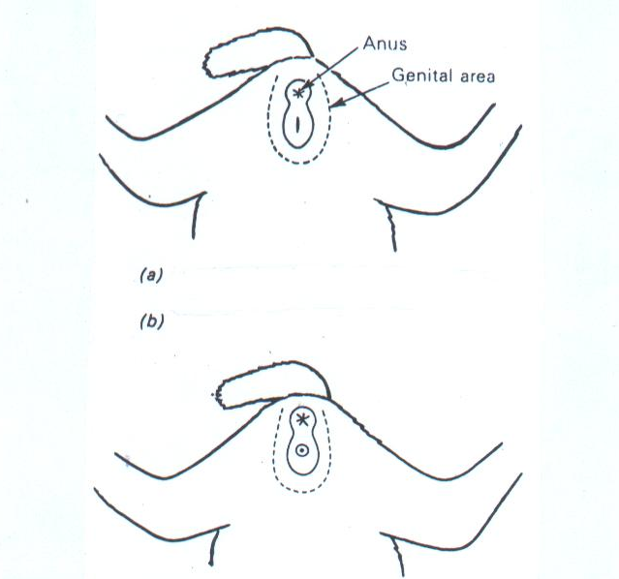
Sexing a rabbit a) in a female the organ is slit-like. b)in a male it is rounded.

Age determination تقدير العمر فى الارانب
This occurs by three methods توجد ثلاث طرق لتقديرالعمرفى الارانب
1-the best and the most accurate method for age determination in rabbit is that method which is depend on the date of birthافضل وادق طريقه وهى التى تعتمد على معرفه تاريخ الولاده
2-The claws of the rabbits do not project outside the fur covering until the age of maturity, they continue to grow and become more curled as age advances.هذه الطريقه تعتمد على طول الاظافر. فى البدايه تكون الاظافر مغطاه بالشعروبذلك تكون غير مرئيه حتى عمر البلوغ وبزياده عمر الارانب يزداد طول الاظافروتصبح ملتويه وغيرمستقيمه
3-the third method depends on the feel of the ears, the animals of one year are distinguished by their softer feel from animals of two or three years of age in which the ears feel slightly tougher. الطريقه الثالثه تعتمد على ملمس الاذن.حتى عمرسنه يكون ملمس الاذن لين بينما فى عمرسنتين اوثلاث يكون ملمسها صلب
Restraint:طريقه مسك الارانب
The most common method is to grasp the ears close to the neck skin with one hand, and the rear quarters are supported with the other
For young rabbits up to about 3 or 4 months, grasp the animal across the loins. This method is not suitable for large rabbits and particularly, does in kindle
For longer distances, the rabbit is placed on the bearer's forearm with its head concealed in the bend of the elbow.
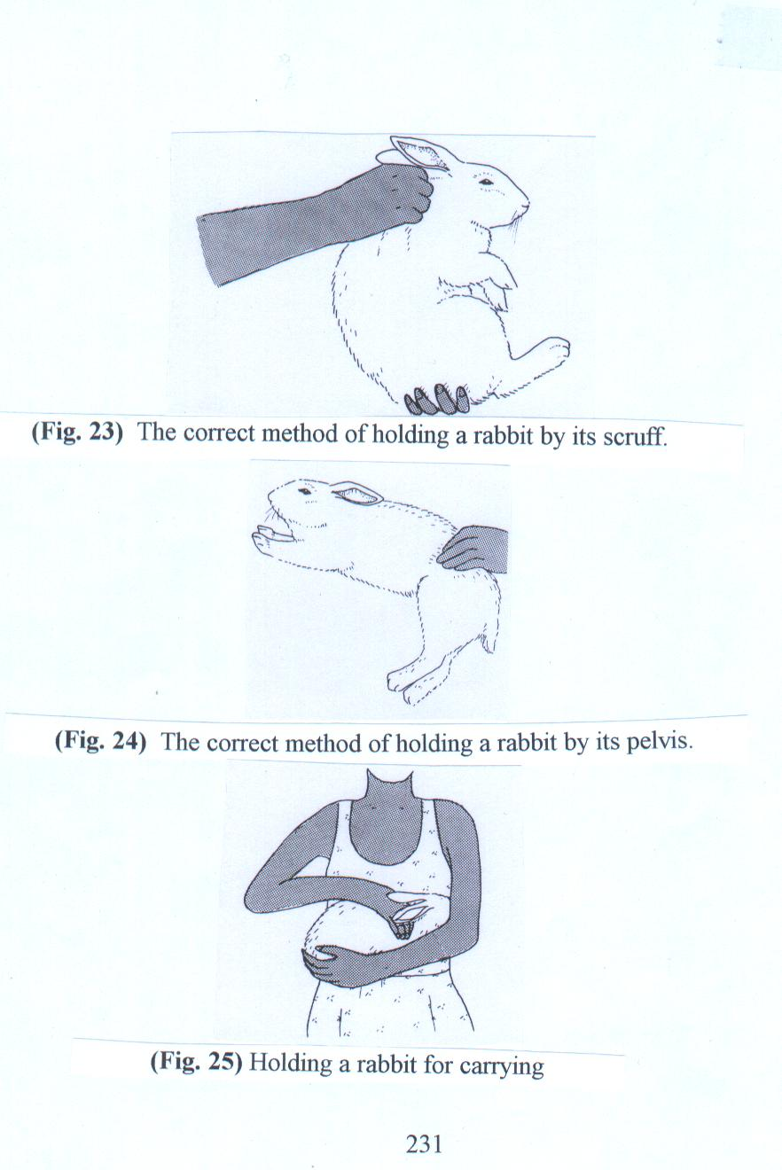
The correct method of holding a rabbit by its scruff.
The correct method of holding a rabbit by its pelvis.
Holding a rabbit for carrying

Feeding:
A rabbit's teeth are adapted for gnawing القرضand as they are growing throughout life, فى نمو مستمرso need foods which will wear them downتحتاج نوعيه من الغذاء تساعد على تاكل الزياده فى طول الاسنان. The rabbit is a herbivore,حيوانات عشبيه or plant eater, and its digestive system is therefore adapted to coping with fibrous plant matter such as grass or hay. Like all animals, rabbits need protein for growth and body repair, carbohydrates and oils for energy and warmth, vitamins and minerals for the maintenance of good health, and water at all times.

Importance of fiber in rabbet feeding
اهميه وجود الالياف بنسبه عاليه فى علف الارانب
For good health state
Wears the teeth and helps to maintain normal dental occlusionتاكل الزياده فى طول الاسنان والمحافظه على شكل ووضع منتظم للاسنان
Increase the rabbit’s appetite for caecotrophsاكل الفضلات
For normal intestinal motilityللحركه الطبيعيه فى الامعاء
.

Deficiency in fiber in rabbit feeding
Depress appetite or decrease food intake
Dental overgrowth and dental malocclusion
Fur eating → hair ball formation ( trichobezoars) نقص الالياف يؤدى الى ابتلاع الشعروتكوين كور من الشعرداخل الامعاء
Intestinal hypomotility → slow movement of food through intestine → multiplication of pathogenic microorganism→ production of toxines→enterotoxaemia وجود نقص فى الالياف يؤدى الى ضعف حركه الامعاء وبطئ حركه الطعام مما يؤدى الى زياده نمو البكتيريا الضاره وانتاج السموم داخل الامعاء
If fiber deficiency is accompanied with high starch this lead to retardation of food inside intestine due to intestinal hypomotility and multiplication of pathogenic microorganisms , resulting in fermentation and toxin production. اذا كان نقص الالياف مصحوبا بزياده فى النشا, ادى ذلك الى تأخرمرور الطعام فى الامعاء نتيجه ضعف حركه الامعاءوبالتالى تتكاثرالبكتريا المرضيه فتنتج حاله التخمرلوجود نسب عاليه من النشا وانتاج السموم داخل الامعاء

The best type of feeder for pellets is the hopper, which is fitted onto the hutch of cage mesh and can be filled from the outside while the rabbits have access from the inside

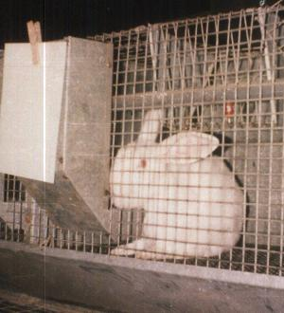
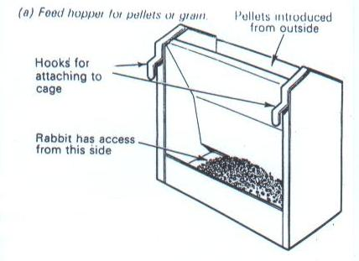
Rabbit eats from the hobber

Rabbit food presents in the form of pellets
Advantages of feeding of rabbit on this form of food (pellets)مزايا استخدام العلف المحببفى الارانب
Easy method of feedingطريقه سهله فى التغذيه
Little waste يقلل الفاقد فى العلف نتيجه وجوده فى صوره متماسكه
More palatable to rabbits مستساغ الطعم
Balancedمتزن فى تركيبه لاحتوائه على العناصر الغذائيه اللازمه
Available متاح طوال العام وغير مرتبط بوقت معين
Presents with a different composition to be suitable for the state of productionيوجد منه تركيبات مختلفه تتناسب مع الحاله الانتاجيه للارانب

.
Coprophagy: ظاهره اكل الفضلات
Coprophagy refers to the ingestion of fecal matter. The normal healthy rabbits produce two kinds of faecal pellets, one hard and this is normally seen on the floor of the cage and one soft; the soft feces is eaten directly from the anus as it is excreted, usually when the rabbit is unobserved.
The practice of coprophagy is similar to rumination practiced by ruminants in the sense that it provides a method of passing feed stuffs through the digestive tract a second time. It is sometimes referred to as pseudorumination.
The coprophagous pellets contain 3.5 times as much crude protein as the normal pellets, but only a third of the fiber, in addition the coprophagous pellets contain considerable amounts of B complex vitamins.
Rabbits begin the practice of coprophagy when they begin eating solid feed at about three to four weeks of age. The practice is normal in rabbits and does not indicate any nutritional deficiencies.
Water requirements of the rabbit:
Rabbits need a good supply of clean, fresh water at all times. A commercial rabbitry should use an automated water system to meet the water needs of rabbits. Rabbits usually consume 2.5 to 3 times more water than dry matter.يستهلك الارنب من ضعفين ونصف الى ثلاثه اضعاف حجم الاكل الجاف المستهلك
Water consumption increases in hot air temperatures and when the diet contains higher levels of protein and fiber

If the water supply is limited, feed intake is reduced.
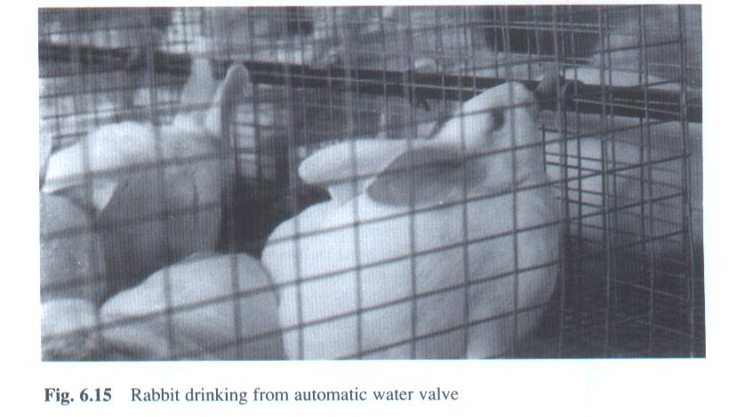
Rabbit drinking from automatic water valve

The care of the doe in kindle (pregnant doe):
After mating the doe should be returned to her hutch and avoid any rough handling or bad management during the period of pregnancy . Her feeding during pregnancy will change. The suitable protein content is ranged from 16-18% and the amount of food is increased by one third at the start of pregnancy and increased gradually to reach to the double of the normal amount (example doe eats in the normal state 60grams food , when become pregnant the amount of food is increased by one third (20 grams) at the beginning of pregnancy so become 80grams and increased gradually to reach the double amount of normal(60) ie 120 grams معنى ذلك انه اذاكانت الانثى تستهلك 60 جرام من الطعام فى الظروف العاديه اى قبل الحمل فبمجرد حدوث الحمل تزاد هذه الكميه بمقدار الثلث اى تزاد بمقدار 20 جرام لتصبح 80 جرام ثم تزاد تدريجيا خلال فتره الحمل لتصل فى نهايه فتره الحمل ضعف الكميه العاديه اى 120 جرام
At the end of the third week, the hutch should be thoroughly cleaned and a good supply of bedding material is given to the dam together with a nest box. The doe will make her nest by carrying bedding material in her mouth and forming a hollow mass from it. After that she will line the nesting material with fur plucked from her breast and belly.
There are some does which abort their young or scatter them at birth or eat them, and this is sometime occurs due to disturbance. So avoid any disturbance at the end of pregnancy or at the time of parturition
The care of the doe and litter:
The size of the litter may vary between one and 15 or even more, although between 4 and 10 are more common. The maximum number of young to be left on the doe will depend on some extent on the age of the doe, as well as the number of her previous litter. Fostering is needed when the number of litter is more than 8 or 10 (because the number of nibbles in doe rabbits is ranged from 8-10العدد المناسب للام يتراوح من 8 الى 10 وذلك لان عدد حلمات الام هو من 8 الى 10 ) Foster does are often selected from the popular marked varieties, that is Dutch or English.
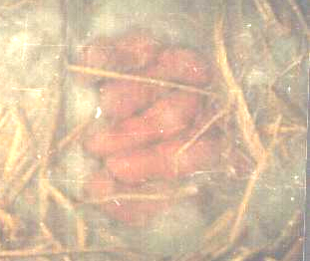
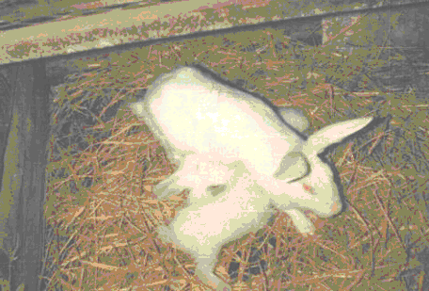

Protein content for lactating doe rabbit food is 18%
Start to feed lactating doe rabbit double amount of normal food at the beginning of lactation and incrase the amount gradually till reaching three amount of normal food (ex doe rabbit eat 60 grams food , the suitable amount at the beginning of lactation is 120grams this amount should be increased gradually till reaching to three amounts of the normal food ie 180 grams)
From the second day of birth we must inspect the nest to observe the condition and the number of the young and to remove dead and deformed young and the uneaten placentas يجب فحص الصغار بعد يوم من الولاده بعد اخذ الاحتياطات التى سنذكرها فى المحاضره القادمه ان شاءالله وذلك للتاكد من صحه الصغار وعددهم للتاكد انه مناسب لان ترعاهم الام وكذلك للتخلص من الاجنه الميته و المشوهه وكذلك المشيمه التى لم تاكلها الام

